TASKSTREAM FOR STUDENTS
- Type the following into an internet browser: http://ecourses.pvamu.edu
- Login to eCourses using your PVAMU username and password
- Select your courses and click on the “Taskstream Student Access” link
  - NOTE: eCourses allows you to access Taskstream system directly, without an additional login
  - If you have never used Taskstream before, you may have to read a displayed Taskstream User Agreement, then click on the I Accept Agreement button. The next page will ask for required information: email address, home/cell number, password, password hint (NOTE: This information is for accessing Taskstream directly without going through eCourses. This does not affect your PVAMU email password)
- A new window tab will open:
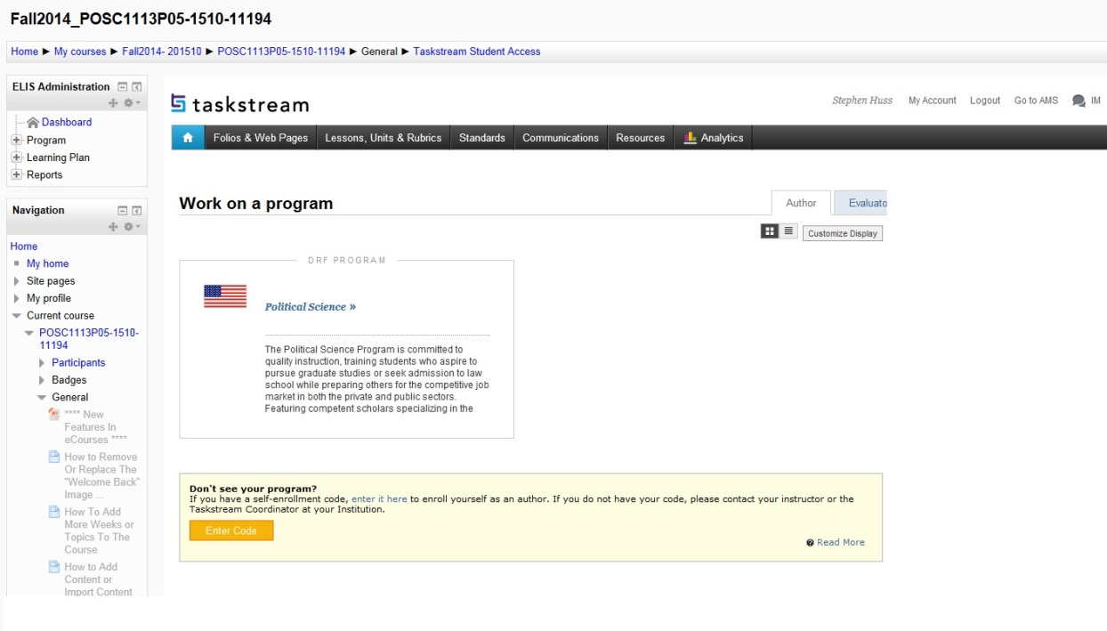
- A DRF Program in Taskstream is the PVAMU department that offers the specific course. Select Political Science and the following screen will display: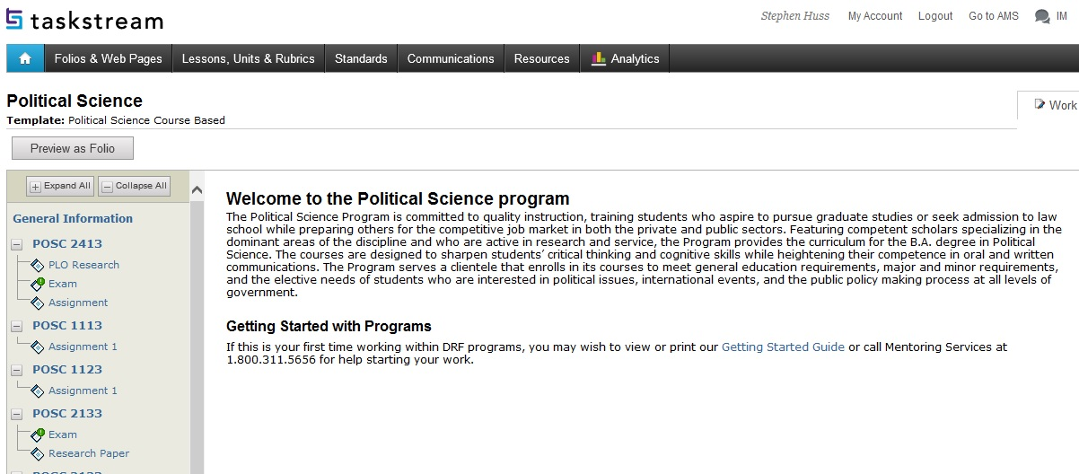

Note that only the course you are currently enrolled in should display, either POSC 1113 (American Government I) or POSC 1123 (American Government II).
- There are three tabs listed in the upper right corner of the screen: Work, Scores/Results, and Options. You will start out under the Work tab.
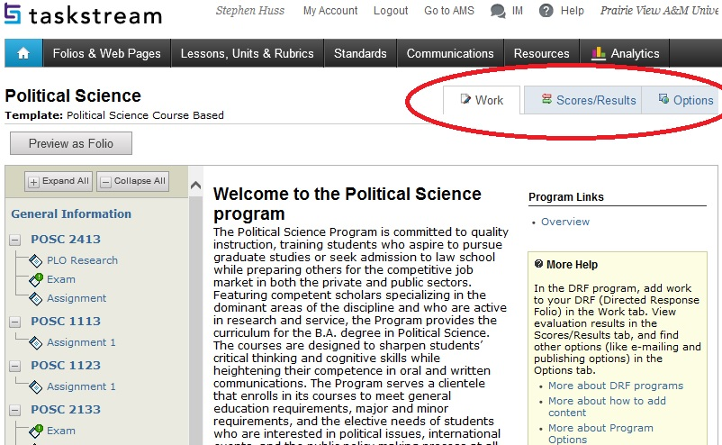
- Select the assignment specified by your instructor. This is Assignment 1 listed under your course (either POSC 1113 or POSC 1123).
- This assignment is setup with specific types of content that can be uploaded. The bar at the bottom of the page lists the options available. Attachments is the most commonly used and will allow you to upload your word document. Click on Attachments.
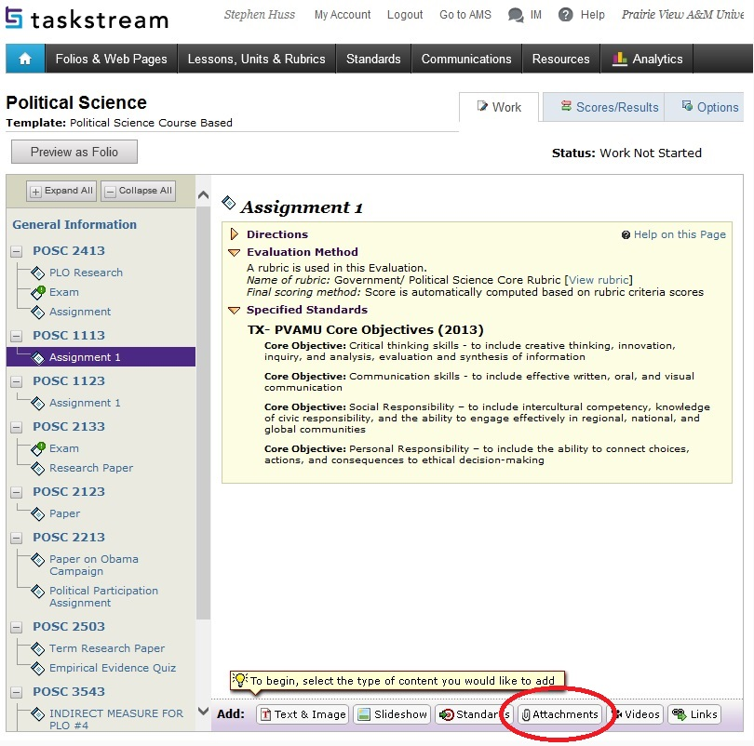
- You are now at Add/Edit Attachments for Assignment 1. Use the Add New Attachment tool to select a file saved on your computer or USB drive. Click Add File. Once the file has been attached, it is listed under Currently Attached Uploaded Files. You may then click Save and Return.
- ONE MORE STEP, you are not complete. Click the orange Submit Work button as shown below:
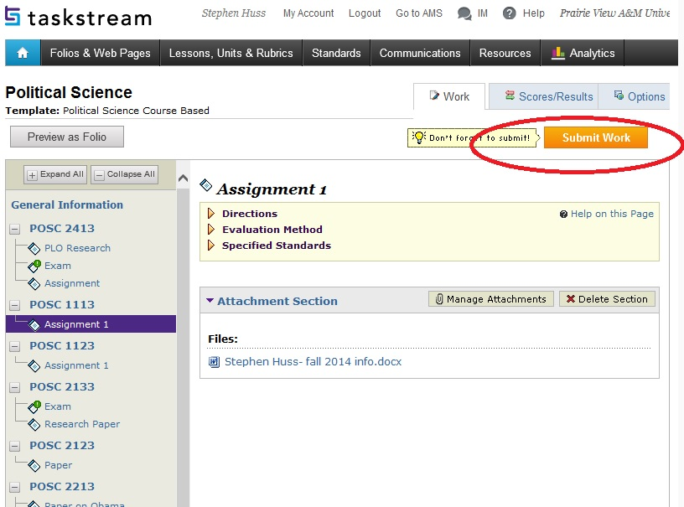
- There should be a final confirmation pop up window. If you are ready to submit, click the Yes-Submit My Work button to complete the process.

